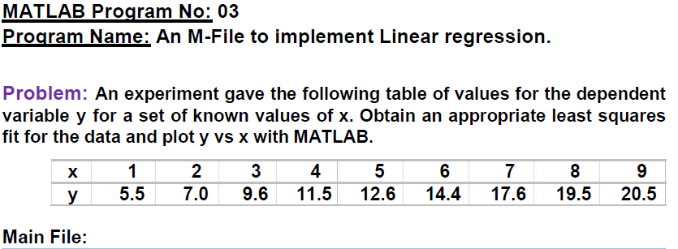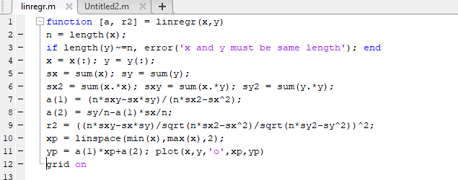

**Input File:**

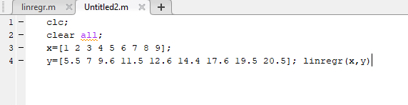

**Output:**

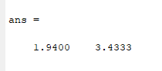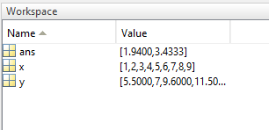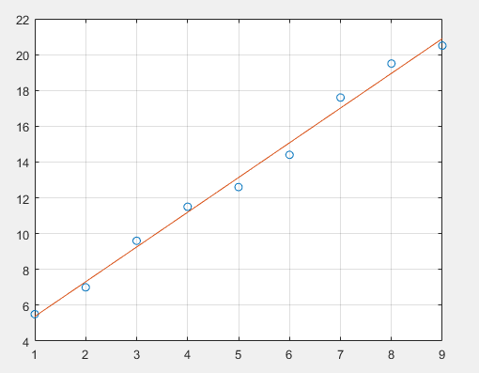

1. **What is least squares approximation of functions? Explain it.**

**Least squares method**, also called **least squares approximation**, in [statistics](https://www.britannica.com/science/statistics), a method for estimating the true value of some quantity based on a consideration of [errors](https://www.britannica.com/science/error-mathematics) in observations or measurements. In particular, the line (the function yi = a + bxi, where xi are the values at which yi is measured and i denotes an individual observation) that minimizes the sum of the squared distances (deviations) from the line to each observation is used to approximate a relationship that is assumed to be linear. That is, the sum over all i of (yi − a − bxi)2 is minimized by setting the partial derivatives of the sum with respect to a and b equal to 0. The method can also be generalized for use with nonlinear relationships.

**2. Why it is important for an engineer?**

Ans: Linear regression attempts to model the relationship between two variables by fitting a linear equation to observe data. A linear regression line has an equation of the form

Y= a+bX

Where X is the explanatory variable and y is the dependent variable.

Actually by using this method we can relate between two variable and can understand the relationship of them graphically.